Modelling Cyber Security and Resilience in Complex Systems
Angela Mison

Introduction
Kennedy et al (2001) define complexity as:
The interaction of many parts of a system, giving rise to behaviours and/or properties that are not found in the individual elements of the system.
Considering the position and classification of connected and autonomous vehicles (CAV) as IoT devices in the road transportation system, open to connections to and from an undetermined number of sources, it highlights the hierarchy of complex, complicated systems and the unified (complete) complex systems as a whole and its properties and behaviours and that different aspects of complexity theories available may be relevant to resolution of problems.
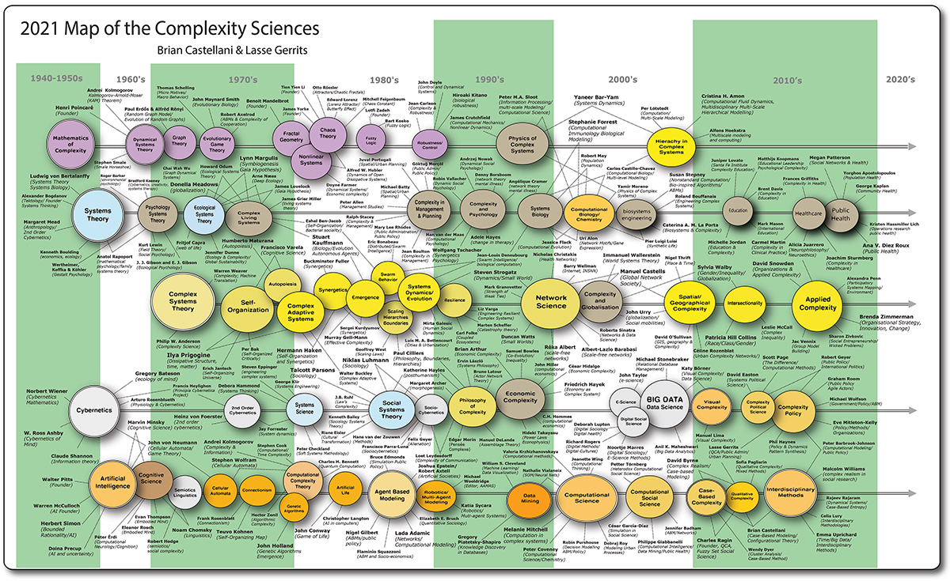Figure I 2021 Map of Complexity Sciences (Castellani & Gerritts, 2021)
Complex systems are composed of many component systems and have distinctive properties of non-linearity, emergence, evolution. It is their interaction with their environment and interdependencies between their components which renders them complex as it can lead to unknown and unpredictable events.
The components of a complex system may be complicated systems by which is meant that there is no direct interaction with the environment, but this does not negate that such interactions on the part of a complex system may have consequences to the complicated system. An example of this may be given by malware which alters the length of, or suppresses parameters presented as input to or within the complicated system.
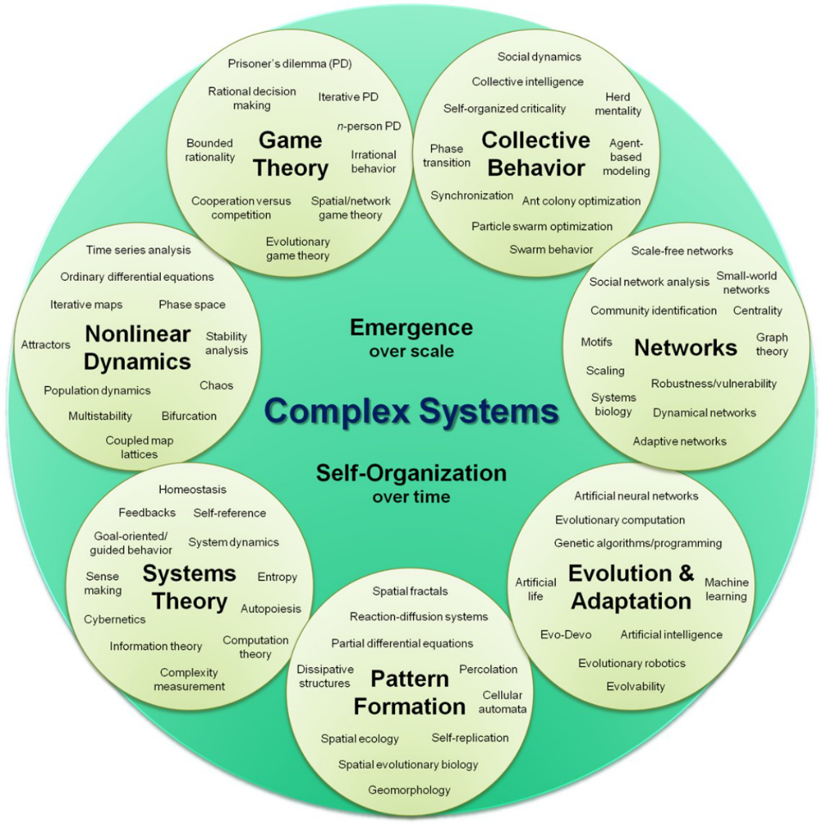
Figure II Components of a complex system (Antonopoulos, 2016)
In the road transport system, both complex and complicated systems coexist as multi-level systems, whose rules or invariants may not be compatible. Systems have been developed over time and by a number of manufacturers. The historical nature of the complex cyberphysical system that is the road transport system has been controlled by a human, either a driver or system developer with knowledge and bias about culture and behaviour.
Inherently there is enormous diversity in such systems which have depended upon the flexibility offered by human intelligence to respond, sometimes badly, to undefined situations. In moving to CAV, it is necessary to build or constrain this flexibility in the operational or functional complicated systems.
Currently there are a disparate number of neural networks within a vehicle. These advanced driver assistance systems cut out the driver in certain circumstances. They were developed to aid in the reduction of accidents, approximately 95% of which are attributable to human error (Office for National Statistics, 2018). An example of such a system is the collision avoidance system which in relevant circumstances disables driver input other than as a steering function, though even this is under development.
Safety will not necessarily be a consideration in the model. To quote Donnelly (2020):
Safety is designed to protect people from machines, security is designed to protect machines from people.

Typology

Complicated Systems
Complicated systems are largely machine based, mechanistic systems in which it may be possible to
- Design the system
- Make predictions about behaviour of such systems
- Control responses to various inputs.
From the perspective of a complicated system, it may present as seemingly complex through its interactions in which inputs arrive from interacting systems. In order to model the braking system, initially the system will be modelled as a complicated system, a system in normal operation, which inputs can be trusted to be valid, in context and applicable. Subsequently, the model will be extended to consider the consequences of externally influenced inputs.

Complex systems
Complex systems are those that have interactions outside their system boundaries and which may contain component systems. In comparison with complicated systems, complex systems are characterised by their system boundaries, which are applicable to both the complex system and its components, and can be defined thus:
System boundary definition
System_boundaries :: {{properties}, {behaviours}}
Properties :: {{entities}, {interactions}, {relationships}, {dependencies}}
Behaviour :: {[entity entity]}

Invariant on system boundaries
∀e ∊ {entities} ∧ ∀b ∊ {behaviour} . b ≠ [e e]

(this invariant prevents a non-terminating loop as something in the entity must change eg a counter, which information may be used to terminate the loop, or if acceptable, reinforce a behaviour)

Complex Adaptive systems
Entities outside the boundary form the environment. Application of the boundaries and constraints should preclude the system from becoming a complex adaptive system with emergent properties, thus is amenable to the historical development process. If deep learning is involved in a constituent part of the system, the invariant may not hold as the system adapts to its environment and the sets relating to boundaries increase without reference to the imposed invariants.
Where the boundary invariant or constraint does not apply, the likelihood is that a complex adaptive system will emerge.
Unconstrained interactions may give rise to:
- Unpredictability
- Emergent properties
- Undefined behaviours and failure of functionality
- Creation of new orders
- Creation of new structures
- Creation of new ways of working
- Being distanced from previously defined equilibria and as such may no longer work under previously defined rules and constraints or they may, disastrously, increase functional latency in the component systems. Complex systems may not be able to dictate or know the possible outcomes to undefined inputs. The new equilibria may be far removed from those initially defined and there may be no path back to the original definitions.
- Necessarily being adaptive in that interactions with other elements of a complex system may create interdependencies within the overall system. They are evolutionary.
- Defined by uncertainty, unpredictability and evolution. The consequences of operation may not be understood.

Emergent properties
Goldstein (1999) provides a definition of emergence as
the arising of novel and coherent structures, patterns and properties during the process of self-organization in complex systems
Emergent properties are a result of system of evolution and can be identified when a complex system reacts in a way that cannot be predicted from its component parts. This is exacerbated by the involvement of neural networks giving rise to adaptive systems within the component system hierarchy.
Perhaps an example of this is the structure of the brain, composed of interacting neurons. The analysis of a neuron, what it is and how it works is possible at the functional level. At what point can it be predicted from the interaction of neurons that would arise consciousness, morality or other attribute such as the ability for movement and language, even if these possibilities were known in advance?
A further example may be the change of state of matter between ice and water. At some temperatures, a change in temperature may not achieve a change in state, but as the temperature of the ice approaches melting point, even a small change in temperature can achieve a major change of state.
The interactions which drive emergent properties are qualitatively different, providing new possibilities and potentially requiring new constraints. Emergent properties occur at the edge of chaos thus the system may be non-deterministic at that point. There are issues arising from this novelty, such as computability and as such it may be determined that computability cannot be defined for complex adaptive systems.
In the initial model, the boundary invariant will be applied in order to avoid defining a complex adaptive system and to provide the behaviour of the model under standard operational conditions.

Computational problem
To quote (Yu, 2018) a systems' theoretician:
Complexity is the prodigy of the world. Simplicity is the sensation of the universe. Behind complexity, there is always simplicity to be revealed. Inside simplicity there is always complexity to be discovered.

Bearing in mind the definition and constraints of the unified system, the initial system definition for modelling purposes is intentionally generic. What will render the generic specific is the exact system under consideration and its boundaries. As defined, the solution could be applied to a program, a component system, a set or hierarchy of component systems or to the complex system as a whole.
While (Corning, 2002) provided further detail of emergence, he also suggested that:
Rules, or laws…..serve merely to describe regularities and consistent relationships……..you cannot use the rules to predict 'history' – i.e., the course of any given game…[T]he 'system' involves more than… rules of the game. It also includes the players and their… decisions among a very large number of available options at each choice point… [and] feedback-driven influences. It is not simply a self-ordered process; it involves an organized, 'purposeful' activity.
To constrain both the system and the model, consideration is given to computability and computation. The system will be modelled on the basis that emergent properties are outside scope, with the caveat that admitting of any such emergent properties arising from the interactions of a complex system will be considered post hoc when such properties have been identified and assessed, but shall not be permitted to execute intentionally prior to this assessment.
Computational complexity concerns the functionality of a system, not necessarily its properties or behaviours, although these act as invariants on the possible elements, properties, outcomes, and behaviours which comprise the system. Some aspects of the computational rule can be mapped directly back to the unified system boundary definitions in terms of behaviour, as in choice and input and output as in the set of interactions.
The following owes much to Barrington (1989) whose theorem applies to a rooted directed acyclic graph. In the case where two states, [s s'], as in the defined invariant, cannot have the same value, the system may become a DAG, it is a matter of implementation. Of note is the absence of the concept of properties and behaviours, which in the system structure definition can be attributed to the variables and enforced by the invariant. In such a case, the theorem reduces to a mechanism for navigation of a DAG, although subsequent use of the theorem in work associated computational complexity indicates this is a trivial interpretation. The theorem is explained by Fortnow (1994) thus:
A branching program is a rooted directed acyclic graph where each internal vertex is labelled by a variable name and for each input there is a single edge leaving that vertex labelled by that symbol. The leaf vertices are labelled 'Accept' or 'Reject'. The machine proceeds along a root to leaf path by examining the input of the current vertex's label and then follows the edge corresponding to that value. The machine accepts or rejects when it comes to the corresponding leaf vertex.
System Definition
System :: [(input, state, algorithm) (output, choice)]
Complex_system, Complicated_system :: {System}
Where (token indicates undefined at this juncture and is used to demonstrate generic applicability)
input : [token]| i : input
output : [token] | o : output
state : [token] | s, s’ : state
action: [token] |a : action
algorithm : action_list | <a> : algorithm
system_function :: f (i, s, <a>) [(i, s, <a>) [o [s s’]]
When it takes the state as an input/context rather than a pure function it defines the dependencies, inter-relationships, and behaviour as in using a particular o, choice (behaviour) is [s s']? with or without then using the o as input for s')
choice :: [s : state s' : state]
System invariant
∃!(i, s, s’, <a>, o, c) | (i, s, <a>) ∊ dom System ∧ ∃!(o, c) | [o c] ∊ rng System ∧ [(i, s, <a>) (o, c)] ∧ f(i, <a>) o ∧ c = [s s’] ∧ s ≠ s'

System performance
In order for any complex system to be implemented, attention must be paid to whether its operation is decidable, computable, and timely given the underlying architecture, problem definition, problem solution, implementation of solution, and available resources.
The rationale for the definitions given here for a complex system is to enable identification and understanding of the characteristics of a complex system. In this understanding, consideration can be given to the reality of the environment, its impact on a system, and a synergy developed between them rather than the exclusive constraint driven approach in current use.
Of particular interest in the definition of models are:
- Complexity theory as it relates to computation: computability, timeliness
- Complexity as it relates to communication

Computational complexity theory
Not to be confused are a complex system and its attributes, and computational complexity theory. A complex system is the result of design of a structure and development toward the solution to a complex problem. In the case of the autonomous vehicle and how it operates in its environment defines the computational problem of implementing something that will abide by the boundaries of the complex system, and achieve the goals determined by the overarching laws that govern the road transportation system.
There is a notable distinction between an instance or input, complete with its solution which represents a response to a specific computational problem and a solution to the complex problem as whole. The following diagram represents the constraints on computation possibility and resources arising from differing complexity classes.

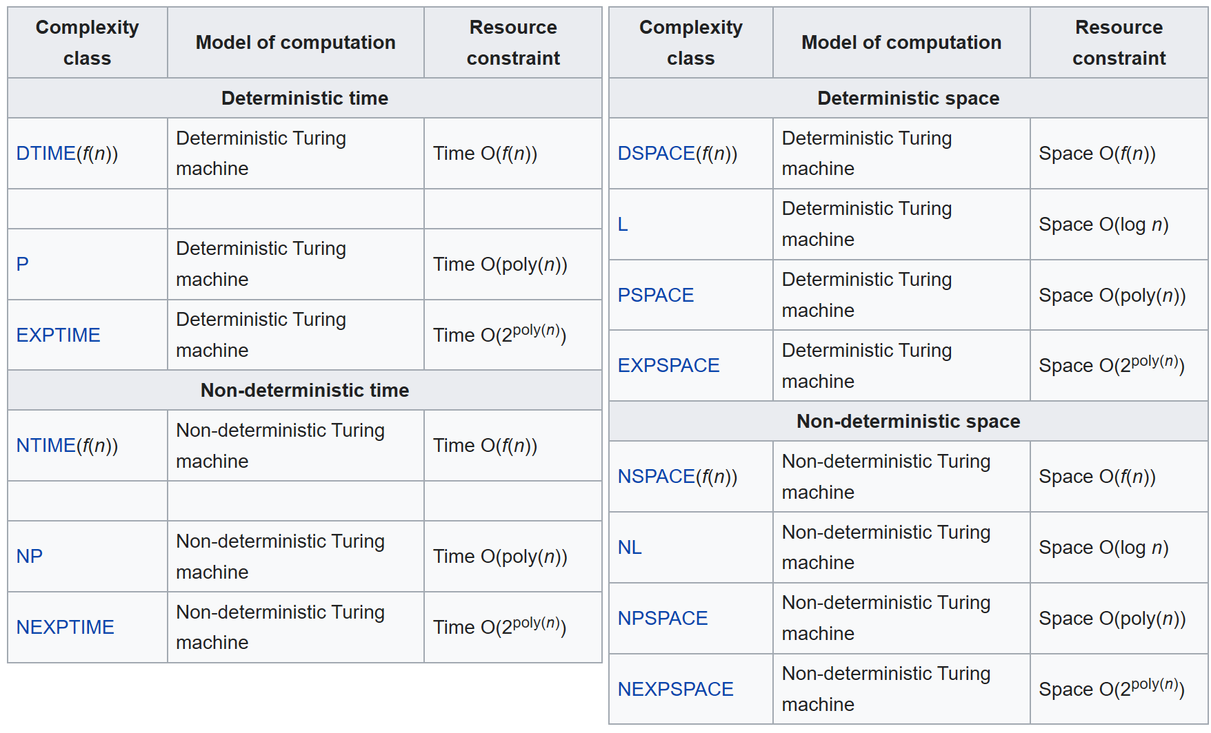
Figure III Complexity class versus computational method and resource constraints (https://en.wikipedia.org/wiki/Computational_complexity_theory unfortunately)
An autonomous vehicle's complex system may have approaching an infinite set of such instances as the algorithms developed to deal with circumstances include more information, input or instances from the operational environment in an attempt to enable autonomous operation. These solutions form an hierarchy addressing the complex problem of the safe operation of the autonomous vehicle. An action must be taken, but which, how, and when?
Without interaction with the environment, such a cyberphysical system as a vehicle’s behaviour and the overarching rule ‘don’t bump into anything’ could be programmed acceptably using swarm algorithms derived from murmuration behaviours, although when this behaviour does not manifest, the consequences are catastrophic
Take, for example, the braking system of a vehicle as defined in Appendix D. If the overarching law ‘don’t bump into anything’ is applied, the inputs which recognise the need for avoidance will come from a myriad of sensors, taking their information from the external environment. This resolves to a straightforward decision problem ‘am I about to bump into something’ which in itself provides the basis of the requirements specification for all and any relevant sensors. The output to this decision problem acts to inform the vehicle that there is actually something to avoid and that other input must be processed to enable subsystems to do something specific as a response.
Where something is detected, other information such as velocity, distance to object to be avoided, spatial awareness, road conditions, tyre pressure, suspension, etc become the input for assessment, of the need to apply the brakes and how strongly, to be incorporated into a computation within interacting complicated systems to provide an appropriate functional solution before the actual activation of the braking system. There may even be an assessment of the need to comply with the rules of the road if compliance with these is part of an overarching schema of laws.
The current ‘simple’ example is the advanced driver assistance system for collision avoidance – when is it sufficient to send some warning signal to the driver and when should the vehicle take over and apply the brakes in an emergency stop? The more ‘complicated’ example might be Tesla’s auto pilot system. From this, it is demonstrated that even the operation of a seemingly self-contained complicated system, such as the application of pads to discs, something quite mechanical, is influenced by input from interactions with the environment.
The complex system represents the structure of the system and its interactions and is the basis for any model. Computational complexity theory addresses if it is possible to resolve the instances taking into account: time, required resources, required storage, functionality, and communication amongst others. It is calculated using a variant of a Turing machine or other specified architecture, which may or may not resolve to a Turing machine.
The rationale for this particular, apparent diversion into computational complexity theory is that there is no point designing and developing systems which do not resolve in a timely manner. Avoiding action to an imminent catastrophe will not wait, despite Xeno's paradox, indicating, in mathematics, movement is an illusion, but which nonetheless has a catastrophic solution in physics (Siegel, 2020).
One of the basics of complexity theory, arising from the understanding that every decision problem has a resolution, provides that the computational complexity of the system under consideration can be adjudged. Whilst most decision problems resolve to a Boolean, function problems of which autonomous vehicles represent an example, relate to a problem where for every input or instance there is a solution, but that the output or solution itself may be complex. Examining computational complexity thus gives an indication of whether a problem is decidable in a finite time, which indication is essential for the safe, secure, and resilient or effective operation of an autonomous vehicle.
In consideration here are the necessary resources to process or compute a solution to a given problem. The results of that consideration are affected by whether there is a single processor, parallel processing capability or alternative architecture, use of which can lead to reduction of overall processing time. Need for optimisation can be determined by use of the computational complexity
System definition
From earlier definition of a system, using the types defined there:
System :: [(input, state, algorithm) (output, choice)]
System invariant
∃!(i, s, s’, <a>, o, c) | (i, s, <a>) ∊ dom System ∧ ∃!(o, c) | (o, c) ∊ rng System |
[(i, s, <a>) (o, c)] ∧ f(i, s, <a>) o ∧ c = [s s’] ∧ s ≠ s'
The elements involved in any consideration of computational complexity are:
- Computational time, T, the time take to execute the algorithms, is calculated, usually using 't', a constant time per executed instruction/action determined by the architecture on which the processing takes place.
Worst case computational time 'T'
∀<a>_{i}, i | (i, s, <a>_{i}) ∊ dom System ∧ f(i, s, <a>_{i}) o | [(i, s, <a>_{i}) [o c]]
∧ n = card dom System
T = ⅀^{n}_{i=0} (len System . <a>_{i} * t)
(this looks more like an algorithm than a logic statement, but the fact that an uncounted loop is not permitted may increase the worst case computational time T. Care should be taken in calculation of computational time as there may be several architectures involved and the computational time is calculated by the summation of computational time for each architecture.

Also the literature suggests that the size of the input (instance) has a bearing on computational time, but here it is calculated by considering the number of steps in an algorithm using a constant time, t, as a straightforward multiplier. I have suggested the inclusion of size of input in the input computational rule.

An average computational time could be calculated after running a series of diverse instances and computing the time taken for each of the series. Whilst an average time may be acceptable within the normal operating contours, it is a demonstration of regular behaviour rather than any individual component behaviour thus the recommendation would be to calculate average -v- worst case time and judge the acceptability of any design decision in the context of the consequences.)

- Space/resources required during processing (dynamic memory)
Processing resources required for a ‘pure’ function can be as minimal as the input, the particular algorithm required, and the output which may even overwrite the input. The price of storage has become such that profligate use of space during processing is now the norm. For many systems, optimisation is an historical requirement. It is a consideration in the autonomous vehicle which in spite of the sophistication of its onboard computing facilities has limited computational capacity. Optimisation becomes a necessity in order to avoid the Bremermann Limit which is defined as 10⁹³ bits requiring processing to solve a problem and which he indicated hold for an integrated circuit having 309 inputs and one output, 2³⁰⁹ > 10⁹³. In (Bremermann, 1962) he states:

Problems involving vast numbers of possibilities will not be solved by sheer data processing quantity. We must look for quality, for refinements, for tricks, for every ingenuity that we can think of.
.
For the worst case scenario, it is necessary to consider both the boundaries and the set of inputs as these may be subject to testing for acceptability, the set of choices available are dependent on the output which may be subject to testing for acceptability as within bounds, and the set of algorithms comprising the program itself. There is also a need for the state to be stored as it is the context for a given operation. As such, there may be a requirement for the choice ([s, s’] to be tested – all testing being the pain of defensive programming

Using the system definition as before together with its invariant, a not even the worst case scenario, ie excluding the defensive programming aspect of comparison against boundary values, the processing resources required are defined thus:

i : input
<a> : algorithm
s, s’ : state
o : output
f: function
processing_requirement : [token]

∀i, ∀<a>, ∀s, s’, ∀o | (i, s, a) ∊ dom System ∧ o ∊ dom rng System
∧ [(i, s, <a>) [o [s s’]] ∧ n = card dom System

f(i, <a>, s, s’, o) processing_requirement

Total_ processing_requirement = ∑^{n}_{j =1} (f(i_{j}, <a>_{j}, s_{j}, s’_{j}, o_{j}))

- Storage (static)
The size and number of inputs or instances has an impact on the resources and time required for computation. As indicated above, for dynamic memory, the boundary values are not contained, but in the interests of defensive programming should be for comparative purposes to validate the input and output values as contextually applicable.

Two possible solutions are given in consideration:
  - The output of an algorithm is not equal to the input to an algorithm
  - The output of an algorithm may also represent the input to an algorithm

i : input
<a> : algorithm
s, s’ : state
o : output
f: function
f(i) size_i
f(<a>) size_<a>
f(o) size_o
f(s) size_s
size_i, size_<a>, size_o, size_s : [token]

Input ≠output
∀i ∊ {input}, ∀<a> ∊ {algorithm}, ∀o ∊ (output}, ∀s, s’ ∊ {state} |(i, s, a) ∊ dom System ∧ o ∊ dom rng System ∧ [(i, s, <a>) [o [s s’]] ∧ n = card dom System
Total_static_storage = ∑^{n}_{j=1} f(i_{j}) + ∑^{n}_{j=1} f(<a>_{j}) + ∑^{n}_{j=1} f(o_{j}) + ∑^{n}_{j=1} f(s_{j}) + ∑^{n}_{j=1} f(s’_{j})

Input = output
∀i ∊ {input}, ∀<a> ∊ {algorithm}, ∀o ∊ (output}, ∀s, s’ ∊ {state} |(i, s, a) ∊ dom System ∧ o ∊ dom rng System ∧ [(i, s, <a>) [o [s s’]] ∧ n = card dom System ∧ x card rng System | [o [s NULL]
Total_static_storage = ∑^{n}_{j=1} f(i_{j}) + ∑^{n}_{j=1} f(<a>_{j}) + ∑^{x}_{j=1} f(o_{x}) + ∑^{n}_{j=1} f(s_{j}) + ∑^{n}_{j=1} f(s’_{j})

Hopefully this accounts for the fact that leaves may or may not produce output, but that output cannot act as an input. I may be double counting the states as well, but my mind can’t quite get round (i, s, <a>) being formed from an o and an s’ – if it matters I think I may need to add the condition y = card rng rng System | s’ = NULL for the ∑^{y}_{j=1} f(s’_{y}) calculation and think about if x = y.
What about <a> : function | <a> (i, s) (o, s’)

Communication complexity
Yao (1979) has provided a theory and formulae for the calculation of communication complexity, which determines the number of communications required to solve a given problem when the input is distributed throughout a system.
In the same way as optimisation applies to programming and storage usage, it is possible to optimise communications and in the case of CAV, minimisation of the numbers of communications between interacting systems should be beneficial for both minimisation of input errors or approximations and security.

Approximate computing
In response to safety requirements, time is of the essence. As indicated previously in discussions on the structure of the system, ordering of inputs may be of concern. In such cases, a default or approximate value may be applied as input. At the point of approximation, it may be that there is a small error which, as it promulgates through the system, aggregates into a sufficiently large error to cause a failure. The error may be amplified at each transition via the dependent algorithms which rely either on it as input, or its results.
In an unconstrained complex system, approximation may cause the system to operate at the edge of chaos with potential emergent behaviours. For example, consider the material state of H₂O which goes from a solid to a liquid and thence to a gas. A small increase in temperature in the stable states such as ice at -20ºC will not alter the state of matter, but if the temperature rises to -2ºC, the application of that same small increase in temperature may result in a change of state from a solid to a liquid.
Within a CAV, it is expected that some parameters have a lower tolerance for variation than others, thus approximation without some form of checking or institution of a safe default value could be catastrophic, or at least unforeseen or evolutionary/adaptive consequences, perhaps transgressing the rules for the complex system as a whole. Approximation can be seen as an attempt to secure resilience, should some element be defective, but unless the ultimate consequences of such approximation are know, ie subject to rigorous testing, it remains a questionable tactic.

Which complexity theory or other theories are relevant and applicable to construct a model?
There are several threads to the study of complexity. Complex systems cross several disciplines such as organisations, social science, mathematics, systems theory, and biology. It is likely that more than one of the threads within these disciplines may be relevant and applicable, or even necessary in the construction of a model of a complex or perhaps complicated system with interactions into other areas of a complex system.
In addition to the above computational complexity theory which must be considered during design, development and implementation, there are additional theories or areas that warrant investigation such as:
- Complexity theory and organisations as it relates to strategy
- Complexity theory as it relates to complex adaptive systems and evolution
- Systems theory
- Information fluctuation
- Whether issues arising in operation are decidable in finite time

Modelling the system
The rules governing both complicated and complex systems are inherently different. Rules concerning a complex system seek to govern and constrain the behaviour of the system as a whole whilst the rules concerning the complicated systems seek to govern the functionality of the component system in accordance with their requirements specifications.
When considering a unified system composed of a complex system and its complicated components, there should be a statement of constraints and boundaries which determines the permissible elements, their interactions, inter-relationships and dependencies. The unified system (US), to be deterministic, must be defined by boundaries and constraints on behaviour.

Historically the interactions of the complex system have required an overarching constraint which sets and maintains the initial purpose or goal of the system – the control and management of vehicles and infrastructure to ensure a free flow of road vehicles in/on the road transportation system.

Defining utility/goals/constraints of a complex system
Giving credit to (Asimov, 1942), in which he defined the law of robotics, which are used here as inspiration, it is possible to consider overarching constraints on the road transport system
- First Law:
A [vehicle] may not injure a human being or, through inaction, allow a human being to come to harm

- Second Law:
A [vehicle] must obey orders given to it by human beings except where such orders would conflict with the First Law

- Third Law:
A [vehicle] must protect its own existence, as long as such protection does not conflict with the First or Second Law

All component systems must abide by the complex system constraints in their specification and design, though they will have specific rules and constraints related to their functionality, which contribute to the goal thus:
- A vehicle must not bump into anything
  - (First law - reinforced by third law if goal primacy is security of the driver – else this statement presents as a contradiction via the zeroth law, if harm to the occupants of a vehicle or harm to an external human is inevitable)
- If there is a space, a vehicle may move into it
  - (First law – an assessment of the possibility of movement - taken from crowd control)
- A vehicle must know where it is going
  - (Second law – in an autonomous vehicle, a destination may be the only acceptable instruction a driver can give)
- A vehicle must obey the rules of the road
  - (Third law – the rules of the road were designed, for drivers, to minimise accidents in the ordinary course of events. The rules of the road do not cover drivers driving beyond their capability, but autonomous vehicles must have the added functionality of assessing their state and environment, en effet situational awareness which causes functional operational limitations on acceptable input parameters to the component systems.)
Asimov defined a zeroth law which is outside the scope of this work.
A [vehicle] may not harm humanity or, through inaction, allow humanity to come to harm. (ibid)
Consideration of this law is useful, in in part arising from enjoining ‘a vehicle must not bump into anything’, as it identifies a circumstance which may force a system to make a value choice. Safety is normally considered from the perspective of the occupant/driver of a vehicle. Primacy of safety from this perspective relates to the occupants of a vehicle.
Where there is a consideration for safety between the occupant/driver of a vehicle and external human life form, resolution of such a potential conflict should be decided by Government, manufacturers or society in general and built into the scheme of rules, not left to the complex system to decide. The zeroth law, in this context concerns the comparative weighting of value of the lives of individuals who will suffer from the effects of reactive adverse latency, however caused, in the complex system.
The value of highlighting this law relates to the existence of situations in which there may be contradictions or conflicts of logic. These need to be anticipated and addressed or otherwise mitigated where they arise in the system exclusive of the philosophical value judgement.

Historical imposition of constraints -v- AI Flexibility
All complicated and/or component systems which form a part of the complex system must be developed to align with the complex system constraints in their specification and design, though they will have specific rules and constraints related to their functionality. The constraints and rules of the component systems must not contradict or be in conflict with the purpose of the complex system, and must be directed towards the achievement of its goal, as stated in the rules above.
Slage (2017), in recognition that Asimov’s (1942) stories act effectively to deconstruct his laws of robotics and thus demonstrate their failure, suggests that instead of such restrictive laws which constrain behaviours, there should be the concept of empowerment.
Part of Slage’s argument is due to the difficulty in the definition of words used, such as harm, so that there is a universal common semantic available to be encoded formally. Empowerment is defined as:
Having the ability to affect a situation and being aware that you can.
He argues that this empowerment should maximise the possible actions available to a machine in order to provide the best solution in a given situation, and that this will result in a new set of guidelines/rules for machines to:
Keep humans as safe as possible.
Everitt & Hutter (2018) can be interpreted as suggesting the distinction between the historical approach as indicated here and Slage's empowerment model resolves to:
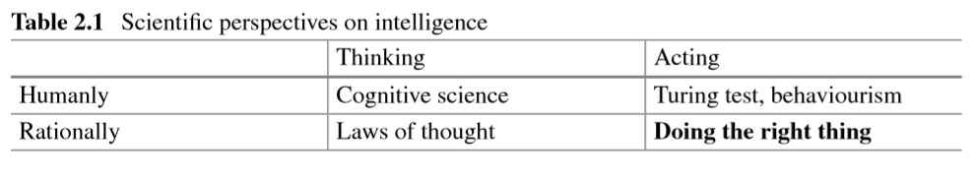
The significant difference between the two approaches is that under the Asimov laws, behaviours, including emergent properties, should be constrained by development, whilst the inference with Slage is that it could be applied to self-learning by machines, given the application of the goals. In either case, the constraints may be present, but the results of the means of achieving goals may lead to radically different systems, although the exhibited behaviours may be largely the same.
Here, to model the system formally, the Asimovesque approach will be used. Such modelling will provide useful material to formulate test suites, the results of which could be compared against results from the Slage approach.

Trust
Interactions between component systems are a microcosm of the complex system. Inputs to a component can be viewed in the same manner as inputs from its environment into the complex system. This caveat brings some doubt to the concept of guaranteed trust within the hierarchy of systems, e.g. is the input from another process valid, and how can authentication and validity be proven?
In the annals of computing history, there developed the concept of defensive programming in which it was assumed that a program user would inadvertently enter some form of error as input. Defensive programming was understood to represent most of the effort protecting the ability of a system to execute in a manner which met its requirements specification by preventing common errors, or errors that could be imagined, from impacting the system. Security by design fulfils the same function in complex systems and the economic cost can be burdensome and human fore knowledge of situational awareness limited, hence the current advocation of trust applied to a complex system.
In a CAV , security in all its forms, must play the part of defensive programming, but in an open complex system, it can be seen that there are potentially infinite opportunities for the introduction of apparent errors, either intentionally or inadvertently without a complete understanding of the consequences. These opportunities are compounded by the presence of errors within the programming itself, and possible computational limitations on encryption/decryption, authentication, and validation.
Given the inevitability of error, wilful or otherwise, security reduces to ‘at what point is it safe to assume an input is correct in context and actionable, and what are the economic consequences across the board of that assumption?’ (Ritchey, 1997). This is not simply a question for the development team. The most a model can do is to highlight points where that economic consequence implies additional investment should be made. Trust and communication complexity are close bedfellows.

References
Antonopoulos, C., 2016. Modelling and Anlaysis of Complex Systems. [Online]
Available at: https://www.researchgate.net/publication/308414528_Modelling_and_Analysis_of_Complex_Systems/download
[Accessed 15 September 2021].
Asimov, I., 1942. Runaround. Astounding Science Fiction, March.
Barrington, D., 1989. Bounded width polynomial-size branching programs recognise exactly those languages in NC. Journal of Computer and Systems Science, 38(1), pp. 150-164.
Bremermann, H., 1962. Optimisation through evolution and recombination. In: M. Yovitts, ed. Self-organising systems. Washington DC: Spartan Bools, pp. 83-106.
Castellani, B. & Gerritts, L., 2021. 2021 Map of the Complexity Sciences. [Online]
Available at: https://twitter.com/complexcase/status/1438164024458424320/photo/1
[Accessed 15 September 2021].
Corning, P., 2002. The re-emergence of emergence: A venerable concept in search of a theory. Complexity, 7(6), pp. 18-30.
Donnelly, P., 2020. Private Conversation. Treforest: s.n.
Everitt, T. & Hutter, M., 2018. Universal Artificial Intelligence: Practical Agents and Fundamental Challenges. In: H. Abbass, J. Scholz & D. Reid, eds. Foundations of trusted autonomy. s.l.:Springer Open, pp. 47-66.
Fortnow, L., 1994. My favourite ten complexity theorems of the past decade, s.l.: Electronic Colloquium on Computational Complexity.
Goldstein, J., 1999. Emergence as a construct: History and Issues. Emergence, 1(1), pp. 1-12.
Kennedy, J., Eberhart, R. & Shi, Y., 2001. Swarm Intelligence. New York: Elsevier.
Office for National Statistics, 2018. Reported road accidents, vehicles and casualties tables for Great Britain: RAS50. [Online]
Available at: https://www.gov.uk/government/statistical-data-sets/reported-road-accidents-vehicles-and-casualties-tables-for-great-britain#contributory-factors-for-reported-road-accidents-ras50
[Accessed 8 July 2021].
Ritchey, T., 1997. Scenario Development and Risk Management using Morphological Field Analysis. Cork, Cork Publishing Company, pp. 1053-1059.
Siegel, E., 2020. This Is How Physics, Not Math, Finally Resolves Zeno's Famous Paradox. [Online]
Available at: https://www.forbes.com/sites/startswithabang/2020/05/05/this-is-how-physics-not-math-finally-resolves-zenos-famous-paradox/#113b6d7f33f8
[Accessed 14 August 2020].
Slage, C., 2017. Asimov's Laws Won't Stop Robots from Harming Humans, So We've Developed a Better Solution. [Online]
Available at: https://theconversation.com/asimovs-laws-wont-stop-robots-harming-humans-so-weve-developed-a-better-solution-80569
[Accessed 4 August 2020].
Yao, A., 1979. Some complexity questions. New York, ACM, pp. 209-213.
Yu, G., 2018. The Mission. [Online]
Available at: https://thecommonvein.net/the-common-vein
[Accessed 3 August 2020].

